# Laboratory 1

1. Questions
   1. Write a program to input two integer numbers and display the sum of even numbers between these two input numbers.
   2. Write a program to find GCD (greatest common divisor or HCF) and LCM (least common multiple) of two numbers.
   3. Write a program to display Fibonacci series up to given limit.
2. Introduction

C is a general-purpose high level language. It was developed for the Unix operating system. C is a successor of Basic Combined Programming Language called B language, developed in the 1960s at Cambridge University. B was further modified by Dennis Ritchie at AT&T Bell Laboratories in 1972. This new language was called C language.

**Features of C programming**

* C has many built-in functions and operators that can be used to write any complex code or program.
* Portability is one of the important feature of C language. Program written in one computer can be executed on any other computer.
* C is structured programming language. We can separate your program in different modules. Modularity makes a program easy to debug, test and maintain.
* C has its own built-in library. We can also add our own function to extend library.

1. Algorithms

3.1 A program to input two integer numbers and display the sum of even numbers between these two input numbers.

Step 1: start

Step 2: input two numbers a, b

Step 3: assign sum = 0

Step 4: if a > b

4.1 assign op1=b

4.2 assign op2=a

Step 5: if b > a

5.1 assign op1=a

5.2 assign op2=b

Step 6: for ( i=op1 ; i<=op2; i++ )

6.1 if i%2 == 0

6.1.1 assign sum = sum + i

Step 7: print sum

Step 8: stop

* 1. A program to find GCD (greatest common divisor or HCF) and LCM (least common multiple) of two numbers.

Step 1: Start

Step 2: define function for GCD

2.1 if a == 0

2.1.1 return b

2.2 return gcd( b%a, a) // using recursion

Step 3: define function for lcm

3.1 return (a%b)/ gcd(a,b)

Step 4: input two numbers a, b

Step 5: call function gcd(a,b)

Step 6: call function lcm(a,b)

Step 7: print result

Step 8: stop

* 1. A program to display Fibonacci series up to given limit

Step 1: Start

Step 2: input limit

Step 3: print 0 , 1

Step 4: assign c = a + b

Step 5: while c <= n

5.1 print c

5.2 assign a = b

5.3 assign b = c

5.4 assign c = a + b

Step 6: Stop

1. Program

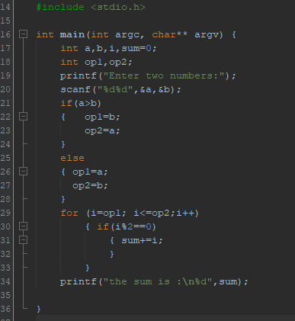

Figure 1 program to print the sum of even numbers between two input numbers.

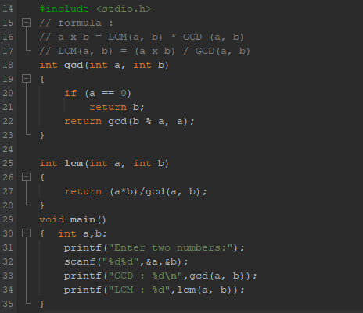

Figure 2 program to print GCD and LCM of two numbers.

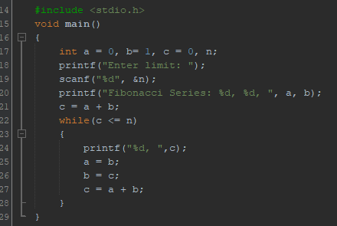

Figure 3 program to display Fibonacci series up to given limit.

1. Presentation of Results

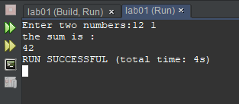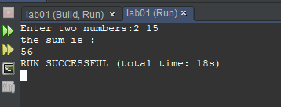

Figure 4 outputs of program to print the sum of even numbers between two input numbers

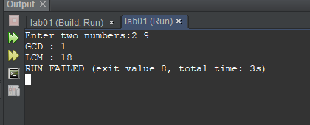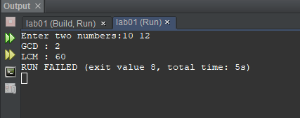

Figure 5 output of program to print GCD and LCM of two numbers.

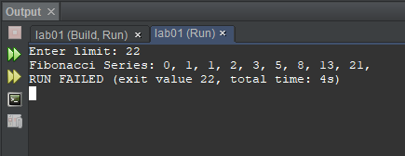

Figure 6 output of program to display Fibonacci series up to given limit.

1. Conclusions

Hence we can see the programs are compiled successfully without any error.

Limitations:

* Difficult to debug.
* C allows a lot of freedom in writing code, and that is why you can put an empty line or white space anywhere in the program. And because there is no fixed place to start or end the line, so it is difficult to read and understand the program.
* C compilers can only identify errors and are incapable of handling exceptions (run-time errors).

As C has some limitations it has many advantages. some of them are:

* Building block for many other programming languages
* Powerful and efficient language
* Dynamic memory allocation feature
* Quality to extend itself